Magic Biography: Ben Rubin
Gary Wise
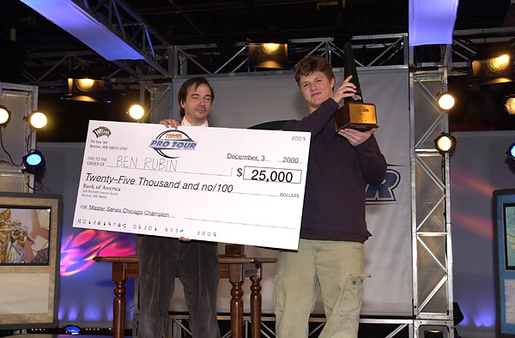Imagine if you would that the greatest players of all time were assembled for one all-star draft. Most of the players involved would be, from an M:tG point of view, historical figures. In games like baseball and basketball, the debate constantly rages as to whether the stars of yesteryear were as good as the stars of today and vice versa, but there is one very pure measure - number of individual Top 8s- by which we can measure a Magic player's career.
Individual PTs
LA 98 - 2nd
NY 98 - 79th
Worlds 98 - 2nd
Chicago 98 - 158th
Rome 99 - 120th
LA 99 - 152nd
NY 99 - 113th
Worlds 99 - 76th
London 99 - 4th
Chicago 99 - 70th
LA 00 - 81st
NY 00 - 3rd
Worlds 00 - 42nd
Chicago 00 - 225th
Team PTs
DC 99 - 70th
NY 00 - 13th
Sitting around this table then would be the 8 players who have 4 lifetime Top 8 finishes or more. There would be Jon Finkel, Darwin Kastle and Mike Long, greats from the origins of the PT right up until the present. Scott Johns and Alan Comer, both still playing with their four Top 8 finishes a piece. Olle Rade, who still makes the odd appearance, would be there for his 5 PT Top 8's, the last of which happened years ago, as would Mark Justice who's last Top 8 finish was at NY '98.
Rounding out this table would be the only new blood to have reached this lofty plateau. Ben Rubin started his Pro Tour career at the ripe old age of 15, with his first PT appearance, LA'98, netting him a second place finish. Looking at that Pro Tour onwards, there can be little doubt that he's consistently been one of the top five players in the game. That's why we now take a look at the life, career and friends that make Ben Rubin a champion.

How it all began...
Ben got his first look at Magic at the age of twelve. It was then, while in sixth grade, that his friend David Agam first introduced Ben to the game. Self-described as ultra-competitive, the young Rubin had never done any gaming previously, with most of his competitive energies dedicated to his competitive pursuits of soccer and casual pursuits of other sports like baseball and basketball.
Agam introduced Ben to the game during school time lunch hours. It was a rude introduction for Rubin, who was immediately given a pile of green cards from which to construct a deck, despite not fully understanding the rules. "Gaea's Liege," remembers the high school student "was the first rare I ever got to play with. He was almost as good as Nightmare. Nothing was as good as Nightmare."

"I've known Ben since he was 12 years old, and can honestly say he's one of the best guys out there. I'm definitely better for knowing him." - Dan Clegg
Once Ben started playing daily, he was hooked. Later that year, he started making his way to San Francisco's Ballpark Sportscards, where he immediately started interacting with other Magic players on a more consistent basis. Among those Ben met there was Dan Clegg, who would go on to be his longest standing Magic friend and playtest partner.
The atmosphere at Ballpark was 'serious-casual,' in that while tournament play wasn't the order of the day, everyone was playing to win. For two years, Rubin learned the tricks of the trade, even being introduced to loose forms of Limited play. Finally, in the 8th grade, Ben got his first opportunity to compete seriously.
That year, Ballpark introduced the Arena League to its players and Ben was hooked. Respected enough for his game that other players didn't really want to face him, no one realized just how good he really was. Playing Standard, Ben would win that inaugural season's championship, instilling in him the understanding that he might have a talent for Magic. During the season, Rubin was introduced to John Castalucci, who showed Ben, Clegg and others the formal ins and outs of Booster Draft.
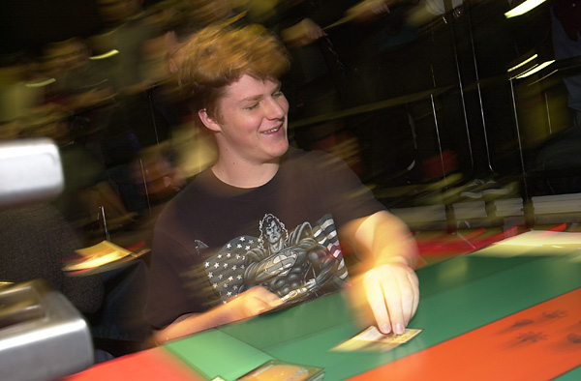
Now possessed of a stronger understanding of the competitive game, Ben decided it was now time to start testing himself. Along with Clegg and a few other friends, Ben headed to the Mirage Prerelease, where he went a respectable 4-1. Unfortunately, in a field of 600 players, his record wasn't good enough to make the cut to Top 32. This disappointment however was not enough to discourage Ben. He desired more tourney play, and he was hooked.
Along with Clegg, Ben started attending multiple tourneys each week, finally building up the confidence to try his first Junior PTQ. While his 5-3 record wasn't good enough to make Top 8, the experience was a valuable one. It was during that season that Ben would be introduced to two future teammates: Trevor Blackwell and Casey McCarrel. "The Juniors were pretty good back then... probably better than the masters," says Rubin.
In his second Juniors PTQ, Ben cleared his biggest hurdle, qualifying for the junior division of PTLA2 It was to be a memorable experience:
'Walking into that PT, I had no idea what to expect. I knew I was decent, but I wondered if I was good enough to compete with the more experienced players there. By the end of the tournament, though, I knew that the PT was something I really wanted to be a part of, if only to have the opportunity to interact with other people with the same competitive nature and love of the game as I have"
In that inaugural PT, Ben finished 33rd, defeating one of the highest-profile juniors - Justin Schneider - on tour at that time. Filled with self-confidence and the knowledge he could truly compete at these levels, Ben, who helped pay for the trip with some small sponsorship agreements and PTQ winnings, went back home with the news of his competitive success and financial failure.
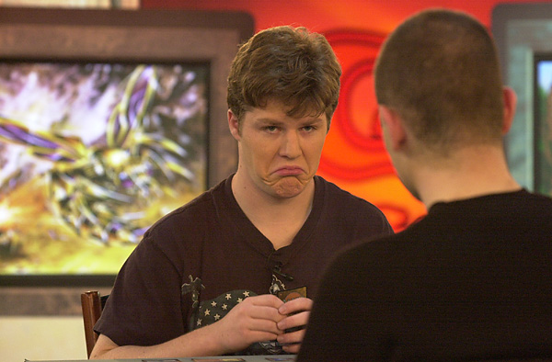
Fortunately for Ben, his parents were supportive despite the obvious doubts concerning a 14-year old traveling alone. When Ben delivered the news that he'd failed to bring home a check, his mother, the daughter of a former Senator, and father, a public relations analyst, cared only that he'd enjoyed the experience. With his family behind him, Ben qualified for his second Junior PT, NY2. He once again failed to finish in the money, coming 34th.
New York was the final Jr. PT to be held, so when the news that Rubin would no longer be able to compete there, Ben took a hiatus. With the level of competition provided by the Pro Tour no longer available to him, there was relatively little that inspired him to play. He played in one PTQ for Chicago, and went 7-0 in the Swiss before losing in the Top 8, but Clegg was able to qualify and soon had Ben doing what he loved best about the game: deck building.
Working hard on Chicago's Extended format, Ben designed Clegg a mono blue deck than ran on Thawing Glaciers, but Clegg went with a questionably configured Necro deck, the end result being a 228th place finish. After that, Dan knew better than to question Ben's deck building ideas, and the results were rewarding. With both players playing in GP San Francisco the same weekend as PT Mainz, Clegg, playing Rubin's Tax/Edge 'Alatar1' deck, finished first in the Swiss. Ben, cruising towards Top 8, lost his final two rounds to eventual teammates Casey McCarrel and Ryan Fuller to miss making the cut.
With Ben now back in the game, he started taking qualifying seriously. He started working during all his spare time on preparing for the LA3 PTQs, and won a qualifier on his second try. It would be the last qualifier he'd ever play in.

Pro Tour highlights
When Ben arrived at PTLA3, little did he understand the importance of that arrival. Playing a Living Death deck that he'd worked on with Clegg, Ben stormed through the Swiss, winning his final five matches. The biggest of these, the final round, in which he was playing for Top 8, came against one of the game's best, Randy Buehler. Buehler's mono-green deck had been built primarily to optimize Cursed Scroll and beat red decks that did likewise. Randy loves to tell the story of the little kid who beat him out of Top 8 in LA and how that kid turned out to be Rubin "That was the biggest match of my life," says Rubin. "Still is."

"He's an unparalleled tactician and he's matured a lot in the last couple years. That means he's more open to ideas than he used to be... I think that means he should continue to have as much if not more success than ever before." - Mark Schick
Rubin went on to finish second, losing to Dave Price. People were asking questions about this kid who'd just fluked his way to a second place finish, but before they could speculate further, Ben came in second again. This time, it was his third Pro stop, at Worlds '98. The last Worlds to be held in Seattle, the tourney saw Ben erase any doubts about his prior success. Playing Sligh in T2, Ben made it once again to the final where he was defeated by another wiz kid, Brian Selden, two years Rubin's senior, but in his first Pro Tour.
After Worlds, Ben was on top of the Magic world. He'd made two PT finals in three events, not to mention beating Jon Finkel in the semi-final at World Championships. Suddenly, he'd been propelled from the rank of scrub kid to that of the Tour's best. Failing to make the Invitational that year due mostly to the Internet vote falling before Worlds, Ben felt he had little left to prove, and it started to show.
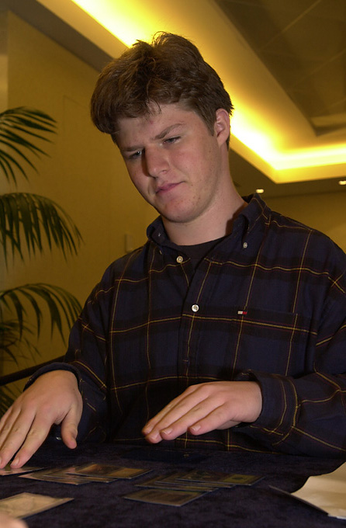
"I was always happy to make top 8 and had no regrets about not winning, so I suddenly had very little left to accomplish." Having gained the World's respect as one of its top players, Ben started on a year he'd sooner forget. Ben's next four tour stops (Chicago2, Rome, LA4 and NY4) saw him finish no higher than 113th, and he didn't fare much better at World Championships, where he finished a disappointing 76th. In order to compete in London, Ben's PT point situation had gotten bad enough that he had to go back to the qualifier circuit, but the quality of his play stood out. In his first try, at Origins, Ben won the sealed deck PTQ, defeating Matt Vienneau in the quarterfinals.
Having earned his way back on tour, Ben was determined to stay on. In London, Ben had his best finish since Worlds98, finishing in 4th place, losing to Thomas Pryor in the semi-finals. The World was convinced that Rubin was back, but there were now whispers that he, like David Mills and Mark Justice before him, could not win the big match. With two day 2 finishes in his next two stops, Ben was turning in solid performances, but it was in NY00 where the world knew once again that Ben Rubin was a premiere level player.
Playing a GW deck he'd designed with Bruce Cowley, Ben was the only player in the top 8 not playing mono-white Rebels or Waters. Before losing to Warren Marsh in the semis, he beat John Hunka in the quarters, leaving little doubt that Rubin, who now had four top 4 finishes was amongst the best the game had ever seen.

"Not only is Ben a good guy, and a good friend, but he has an incredible understanding of the game, and is without a doubt one of the top five players in the world today." - William Jensen
In the meantime, Ben was developing friendships that would help his Pro Tour career immeasurably. Along with McCarrel, Clegg, Billy 'Baby Huey' Jensen, Brian Kibler, Lan D Ho, Fuller and a host of others, Ben formed the Jumble, a team of professionals based on the internet. The Jumble's first concentrated effort came at PTNY4, where the artifact-based Wildfire deck Ben had built with Kyle Rose and Don Gallitz finished first, second, eighth and ninth (in the hands of McCarrel, Shawn Keller, Terry Tsang and Fuller respectively). Ben played with McCarrel and Fuller at PTDC with disappointing results, but the next year, with McCarrel and Jensen, won his first GP, Pittsburgh as a member of Huey, Ben and Casey. It was important because Ben had never won a premiere level tournament to this point, despite all of his success.
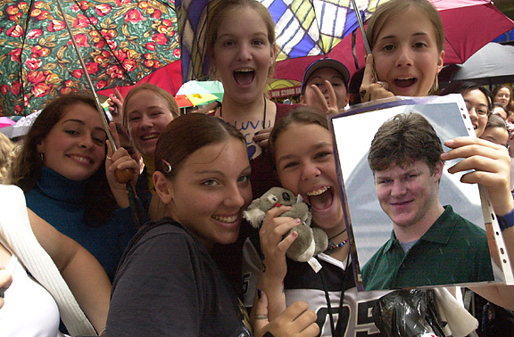
Rubin has a ton of fans in Australia!
Unfortunately, that didn't quiet the whispers. Ben still hadn't won an individual event and the whispers only grew louder with his second place finish in the Magic: the Gathering Invitational, where he lost to Jon Finkel in the finals. Three weeks later though, the whispers quieted forever.
Ben had made it to the third round of the first Masters tournament held in New York, but Chicago was where he made his final breakthrough. The number 4 seed going into the tournament, Ben first beat Igor Frayman, then gained a measure of revenge for London by defeating Thomas Preyer before moving onto the Top 8 draft. Once there, Ben beat Dave Williams, whom observers felt had the best deck at the table, and then defeated Kyle Rose. In the final, Ben faced Jon Finkel in their second final match in less than a month. Rubin, staring at the best player of all time, took it all in stride, defeating Finkel in a finals sweep.
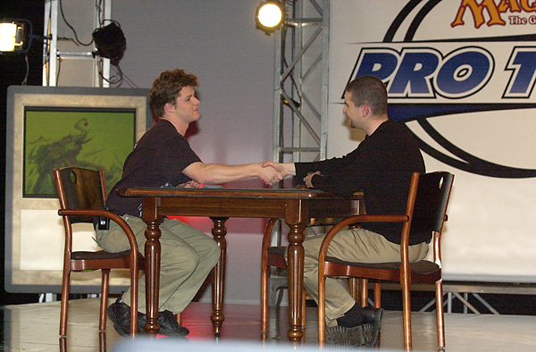
So what's left for Rubin? Undoubtedly he hopes to one day win a PT or World Championships. The 17 year old is looking forward to graduating high school and then possibly taking some time off to play Magic full-time. The big question looming for Ben concerns who he'll work with for Tokyo and next year's team event, neither of which he's certain about, especially with Billy Jensen's decision to play with Brock Parker and Matt Linde, who live a little closer to home. Regardless, one can be certain that with Rubin in tow, his affiliates won't do too badly. They have a champion on their side.

